Friday, November 09, 2018

FOR IMMEDIATE RELEASE

Contact: Kelvin Sampson

309-547-3721

**Selling the War Exhibit Opens at Dickson Mounds Museum**

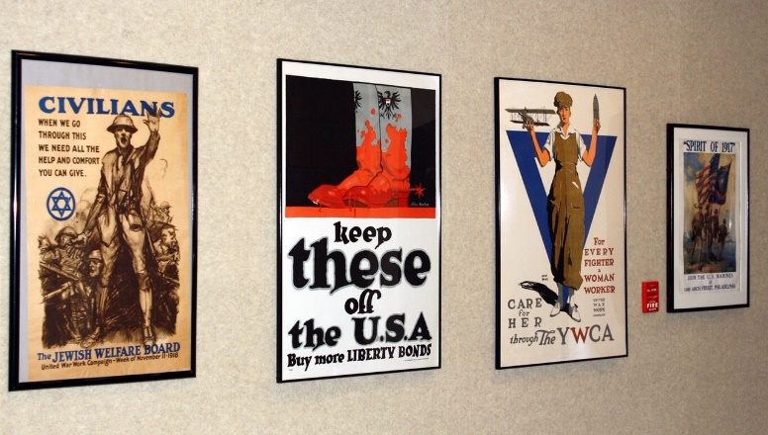

LEWISTOWN, IL – Dickson Mounds Museum is pleased to announce the recent opening of the “Selling the War” exhibit consisting of World War I posters from the collection of Frank Goudy of Cuba, Illinois. This exhibit was created by Dickson Mounds to honor and recognize the centennial of America’s involvement in World War I and it will be on view at the museum through January 31, 2019.

During World War I, the impact of the poster as a means of communication was greater than at any other time during history. The ability of posters to inspire, inform and persuade, combined with vibrant design trends, resulted in thousands of interesting visual works.

The poster was a major tool for broad dissemination of information during the war. Countries on both sides of the conflict distributed posters widely to garner support, urge action, and boost morale.

The Illinois State Museum-Dickson Mounds is located between Lewistown and Havana off Illinois Routes 78 and 97. The museum is open free to the public from 8:30 a.m. to 5 p.m. every day. Tours and special programs are available for groups with reservations. For more information, call 309-547-3721 or TTY 217-782-9175. Also visit us on Facebook at Illinois State Museum-Dickson Mounds or online at the Dickson Mounds link on the Illinois State Museum website at [www.illinoisstatemuseum.org](http://www.illinoisstatemuseum.org).

# # #