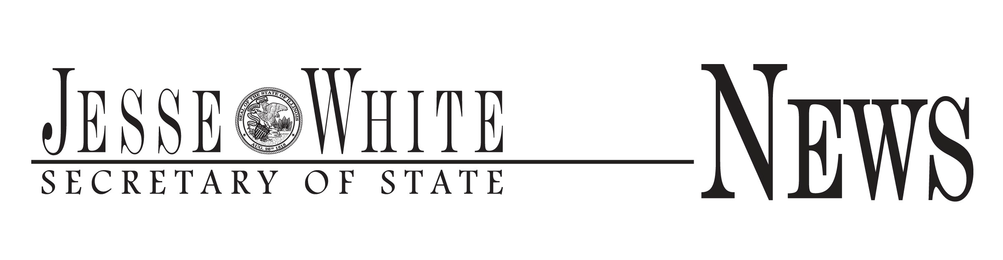

For Immediate Release: For More Information Contact:

June 20, 2018 Rachel French: 312-814-2599

Jesse White Awarded over $550,000 in Illinois History-Digital Imaging Grants

Grant to support the creation and storage of digital collections

Secretary of State and State Librarian Jesse White announced that the Illinois State Library has awarded Illinois History-Digital Imaging grants to 15 academic, public and special libraries totaling $555,305 to carry out projects involving the selection, digital capture and storage of important historical and cultural collections. In addition, the collections will be accessible through the Illinois Digital Archives database maintained by the State Library.

“I am pleased to be able to award these grants in an effort to increase access to significant collections about Illinois’ historical and cultural importance,” said White. “Documents degrade over time. By preserving these materials, future generations will be able to connect past and present.”

Libraries receiving grants are:

• Bensenville Community Public Library District: $31,000 for the “The Bensenville Historical Materials

Archival Project”

• McLean County Museum of History in Bloomington: $94,615 for the “Pantagraph Negatives Project”

• Eastern Illinois University in Charleston: $6,849 for the “Digitization of Local History Oral

Interviews”

• Chicago Public Library: $18,480 for the “Increasing Access through Digitization: The Illinois Writers

Project at Chicago Public Library”

• Roosevelt University in Chicago: $59,050 for the “Digitization of Moving and Sound Recordings of the Illinois Labor History Society”

• Old Town School of Folk Music in Chicago: $13,080 for the “La Peña Concert Series at The Old

Town School of Folk Music, 1995-2005”

• Elgin Community College Renner Academic Library: $10,356 for the “The Gil Renner Collection: Insight into the Genesis of the Illinois Community College System”

• Chicago Horticultural Society - Chicago Botanic Garden’s Lenhardt Library in Glencoe: $73,368 for the “Chicago Horticultural Society Documents and Original 19th Century Scientific Working Papers”

• Highland Park Public Library: $81,024 for the “Ravinia: Music Under the Stars around the World”

• Sallie Logan Public Library in Murphysboro: $13,605 for the “The Murphysboro Apple Festival

Through the Years and the Tri-State Tornado of 1925”

• Methodist College in Peoria: $33,946 for the “The History of Methodist College with Digitized

Primary Objects”

• Plainfield Public Library: $5,003 for the “Preserving Plainfield's History”

• Illinois State Museum Society in Springfield: $12,567 for the “The Story of the Illinois State

Museum”

• Stickney-Forest View Public Library District: $7,520 for the “Stickney Area Local History Initiative”

• Morrison-Talbott Library inWaterloo: $94,842 for the “Monroe County, IL Gardner Survey Records”

Information concerning the Illinois History-Digital Imaging Grant Program can be found at [http://www.cyberdriveillinois.com/departments/library/grants/il-history-digital-imaging.html.](http://www.cyberdriveillinois.com/departments/library/grants/il-history-digital-imaging.html)

###

