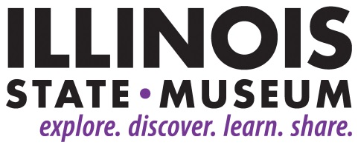

**FOR IMMEDIATE RELEASE**

February 8, 2019

**Contact:**

Elizabeth Bazan

217-558-6696

[Elizabeth.Bazan@Illinois.gov](mailto:Elizabeth.Bazan@Illinois.gov)

**“Museum After Hours” Series Continues with Special Preview Night**

*Exhibit Sneak Peek on February 22*

SPRINGFIELD, IL – The Illinois State Museum in Springfield will continue its evening event series on Friday, February 22 with live music, food and art-making. February’s theme is “Preview Night” in celebration of three exhibitions that open at the Museum the following day on February 23.

The “Museum After Hours” event, scheduled for 5:00-8:00 p.m., will invite adults (21 and older) to view two new art exhibitions and a history exhibit. Guests will have the opportunity to create art inspired by the exhibits to take home, as well as contribute to a community art piece that will be added to the exhibits in the coming months. Last Acre will perform live original folk and bluegrass music. Drinks will include beer from Obed and Isaac's Microbrewery, wine from Danenberger Family Vineyards, and non-alcoholic beverages. Cooper’s StrEATside Bistro will provide their great food truck wares indoors for purchase.

Tickets are $10 for members of the Museum Society and $15 for non-members. All tickets include a beverage, with additional beverages and food available for purchase. Tickets will be available at the door or online at [bit.ly/mahjan2019](https://bit.ly/mahjan2019?fbclid=IwAR0dTJcdHb0ANj6ZLpn_Q8Otmq85S0L-4UUACISFaYD9swgaMNFVGqIzpB0). All proceeds from the “Museum After Hours” series will support educational programs at the Illinois State Museum. Attendees must be 21 or older and must show ID at the door.

For more information or sponsorship opportunities, contact Sarah Davis by email at [events@illinoisstatemuseum.org](mailto:events@illinoisstatemuseum.org) or by phone at 217-782-6044.

The “Museum After Hours” event on February 22 is sponsored by Obed and Isaac's Microbrewery, Danenberger Family Vineyards, and Pepsi.

New exhibits include:

*We Are Illinoisans*, which highlights immigrants to Illinois from the 18th century to today through photos, objects, and life stories. This show will explore the evolving reasons people came to Illinois and experiences of new immigrants through the personal stories of more than a dozen people who left their home states and countries to settle in Illinois. Curated by Erika Holst, ISM Curator of Art and History, *We are Illinoisans* runs from February 23 through June 3.

*Sing Muses: History and Allegory in Narrative Art* features artworks that tell a story through a variety of media. Curated by Douglas Stapleton, ISM Assistant Curator of Art, this exhibit includes highlights from the Museum’s collection, including work by George Klauba, Stanley Bly, Nancy Plotkin, Kevin Veara, and more. *Sing Muses* runs from February 23 through June 3.

*Jeanine Coupe Ryding: Coda for the Day* presents a selection of relief prints, artist books, and collages by Evanston artist Jeanine Coupe Ryding. Ryding is best known for her richly layered, inventive, and often monumental, woodcut prints, 25 of which are included in the show. This exhibit is also curated by Douglas Stapleton, ISM Assistant Curator of Art. *Jeanine Coupe Ryding* runs from February 23 through June 3.

###