**FOR IMMEDIATE RELEASE For more information contact:**

May 27, 2021 Jamila Wicks

P: 217.782.7388

[jamila.wicks@ismsociety.org](mailto:jamila.wicks@ismsociety.org)

**Museum Exhibition Showcases Work of Fiber Artist Sherise Wright**

SPRINGFIELD, Ill. – A new exhibition, Ancestral Threads: The Fiber Art of Sherise Wright, will open on Friday, May 28, at the Illinois State Museum’s Springfield campus. The exhibition celebrates the art and tradition of African American quilting through the work of the late Calumet City, Illinois, fiber artist Sherise Marie Wright.

Wright learned to quilt from her great-grandmother. At three years old, she found herself enamored by the beautiful colors of fabric and the way they sprawled across the floor. With encouragement from her great grandmother, she continued the legacy of Black needlework on her own. Wright later said, “My overall goal as a fiber artist is to create quilts that resonate with my spirit and soul. My quilts are a diary of my heart and spirit.”

“We are honored to present the fiber art of Sherise Wright, which explores her life as an educator, nature lover, and Black artist,” said Museum Director Cinnamon Catlin-Legutko. “The beautifully intricate textiles capture snapshots of Wright’s inspirations. At the same time, Wright’s words that accompany each piece bring her art to life.”

Vincent “June” L.J. Chappelle II, a native of Chicago’s South Side with a lifelong interest in Africana history, is the exhibition’s curator.

“Quilting has been a significant part of Black history for more than two centuries, and it continues to flourish as a way to convey stories and messages. Each stitch carries with it an element of love and care,” said Chappelle. “When I first viewed Wright’s work, I was intrigued instantly. I found myself thinking about the importance of Black needlework. I knew then that I wanted others to know about this seldom-spoken history.”

Ancestral Threads: The Fiber Art of Sherise Wright was made possible by a grant from the Illinois Arts Council Agency, with funding from the National Endowment for the Arts and the Springfield Area Arts Council.

The Illinois State Museum will feature the exhibition through September. Admission is free.

**About the Illinois State Museum**

Established in 1877, the Illinois State Museum is a dynamic institution that inspires the exploration of Illinois’ past and present to inform and enrich everyday life and promote stewardship of cultural and natural resources. Headquartered in Springfield with branch facilities in Lewistown and Lockport, ISM is accredited by the American Alliance of Museums and a proud member of the International Coalition of Sites of Conscience. For more information, visit [www.illinoisstatemuseum.org](http://www.illinoisstatemuseum.org).

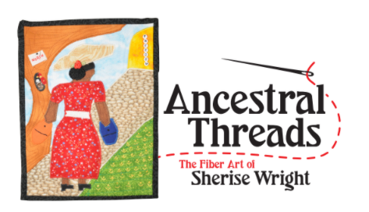

Exhibition Identifiation Image: Heading North in the Springtime, c. 2006  
Sherise Marie Wright  
Cotton and embroidery floss   
Courtesy of Barb Wright and Sheka Wright Boyd, in memory of Sherise Marie Wright

*The inspiration behind this piece was my great-grandmother, Julia, and her love for quilting. I believe faith is what carried so many African Americans forward during the Great Migration. It was as if they were transitioning forward into an unknown life. When we are all pressed to go forward, we take with us pieces that will comfort us on our journey, but the major point is that the sun will rise up to meet us no matter what we are challenged to endure.*

*– Sherise Marie Wright*

###