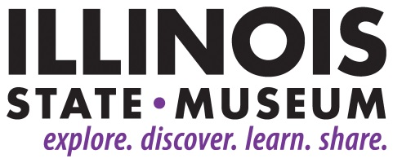

**FOR IMMEDIATE RELEASE**

2/5/19

**Contact:**

Elizabeth Bazan

[Elizabeth.Bazan@Illinois.gov](mailto:Elizabeth.Bazan@Illinois.gov)

217-558-6696

**New Exhibition at Illinois State Museum Features Illinois Artist Jeanine Coupe Ryding**

*“Jeanine Coupe Ryding: Coda for the Day” Opens Feb. 23*

SPRINGFIELD, IL – A new exhibition of the works of Evanston artist Jeanine Coupe Ryding, best known for her complex, monumental woodcut prints, will open at the Illinois State Museum in Springfield on Saturday, February 23.

Ryding’s forms and color record her observations of nature and of daily life. Ryding exploits the difficult medium of woodblock carving to create a wide range of calligraphic and seemingly effortless energetic lines and shapes. Her work is a meditation on the dynamic tension between object and ground, stillness and movement.

The exhibition at the Illinois State Museum presents a selection of relief prints, artist books and collages from the last 10 years of Ryding’s career.

Jeanine Coupe Ryding’s prints and artist’s books are in museums and private collections throughout the U.S., Europe, and Japan. In addition to her artmaking, she has also founded both Shadow Press and Press 928 in Evanston for fine art publishing. She received her BA from the University of Iowa and her MFA from Universitat der Kunste, Berlin, Germany. Her work has earned prestigious awards such as the Illinois Arts Council Award, and she has had residencies at Arts Midwest, the Frans Masereel Center in Belgium, and at Anchor Graphics in Chicago. She’s also been teaching as an Adjunct Associate Professor in the Print Media Department at the School of the Art Institute of Chicago since 1991.

The exhibition will run from February 23 to June 3. The public is invited to attend a “Museum After Hours: Preview Night” event on February 22 from 5:00 – 8:00 p.m. to see this exhibit and two others before they open on February 23. The evening will include live music, drinks from Obed and Isaac's Microbrewery and Danenberger Family Vineyards, and non-alcoholic beverages. Food will be available for purchase.

Tickets for Museum After Hours are $10 for members of the Museum Society and $15 for non-members. All tickets include a beverage, with additional beverages and food available for purchase. Tickets will be available at the door or online at bit.ly/mahfeb2019. All proceeds from the Museum After Hours series support educational programs at the Illinois State Museum. Attendees must be 21 or older and must show ID at the door.

The Illinois State Museum is located at 502 S. Spring Street. It is open Monday – Saturday, 9:00 a.m. to 4:30 p.m. and Sundays 12:00 noon – 4:30 p.m. Admission is $5 for adults ages 19-64.

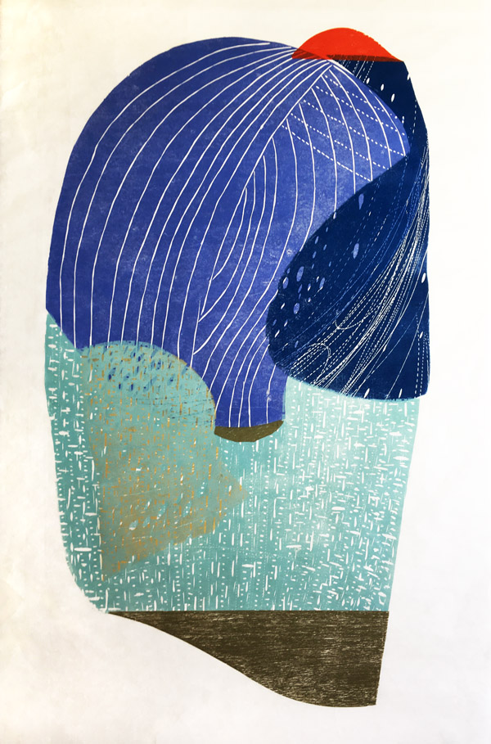

Jeanine Coupe Ryding

*Impending Rain II*

2018

Wood block relief print

57 x 30”

Courtesy of the artist