**FOR IMMEDIATE RELEASE**

May 8, 2018

**Contact:**

Karen Everingham

Karen.Everingham@illinos.gov

217-782-5949

**Illinois State Museum Hosts Gallery Talk and Tour with Susan Weininger on May 23**

*Tour Highlights Gertrude Abercrombie Exhibition*

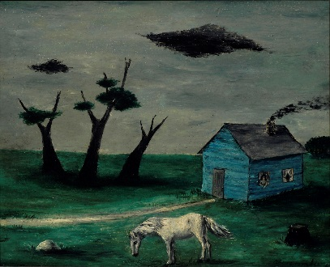

SPRINGFIELD, IL – Join art enthusiasts at the Illinois State Museum in Springfield for an engaging tour of the exhibition “Gertrude Abercrombie: Portrait of the Artist as a Landscape” on Wednesday, May 23 at 7:00 p.m.

The gallery talk and tour will be led by Susan Weininger, the leading scholar and author of multiple comprehensive essays on Gertrude Abercrombie’s art and life. Ms. Weininger will discuss Abercrombie's highly dream-like, symbolic paintings, love of jazz, and involvement in the art world of Chicago in the late 1930s through the 1960s.

The tour is free for those who register in advance by contacting Meghan Lindstrom at [Meghan.Lindstrom@Illinois.gov](mailto:Meghan.Lindstrom@Illinois.gov) or 217-782-0979.

Susan Weininger is Professor Emerita of Art History at Roosevelt University in Chicago. She has curated exhibitions, lectured and written extensively on Chicago artists including Gertrude Abercrombie, Ivan Albright, Tunis Ponsen, Francis Chapin, Romolo Roberti, Paul Kelpe as well as modernist Chicago art in general. She currently serves on the Board of the New Deal Center of Roosevelt University, and on the Illinois Women Artists Project and is a docent at the Illinois Holocaust Museum and Education Center.

The Illinois State Museum is located in the State Capitol Complex at 502 S. Spring Street in Springfield.