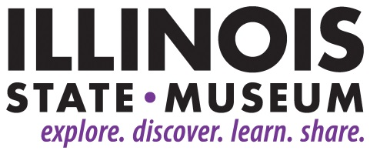

**FOR IMMEDIATE RELEASE**

November 21, 2018

**Contact:**

Elizabeth Bazan

217-558-6696

[Elizabeth.Bazan@Illinois.gov](mailto:Elizabeth.Bazan@Illinois.gov)

**Mining Stone: Exploring Cultural Significance of Mines and Quarries in the European Neolithic**

*Free program at the Illinois State Museum in Springfield on Dec. 5*

SPRINGFIELD, IL – Learn about the history of man through the history of mining during the monthly Paul Mickey Learning Series program at the Illinois State Museum in Springfield on Wed., Dec. 5 at 7:00 p.m.

The free program “Mining Stone: Exploring Cultural Significance of Mines and Quarries in the European Neolithic” will be presented by Lynn Fisher, Adjunct Research Associate in Anthropology at the Illinois State Museum and an Associate Professor of Sociology/Anthropology at the University of Illinois Springfield.

Flint mines and quarries were widespread and important cultural features in the European Neolithic Period (ca. 5500 – 2500 BC), but varied greatly in how they formed, were used, and in regional significance. Professor Fisher’s presentation explores the history of ideas about Neolithic mining, and places of recent research in southern Germany in the context of broader questions about the cultural significance of stone as it was mined or quarried, worked, traded, and used in diverse contexts in Neolithic societies.

Each month, the Paul Mickey Learning Series features a different speaker and topic in the Auditorium at the Illinois State Museum. For additional information, contact [events@illinoisstatemuseum.org](mailto:events@illinoisstatemuseum.org) or call 217-558-6696.