

**FOR IMMEDIATE RELEASE**

2/4/19

**Contact:**

Elizabeth Bazan

[Elizabeth.Bazan@Illinois.gov](mailto:Elizabeth.Bazan@Illinois.gov)

217-558-6696

**New Narrative Art Exhibition Opens Feb. 23 at Illinois State Museum**

*“Sing Muses!” Features Painting, Sculptures and Works on Paper*

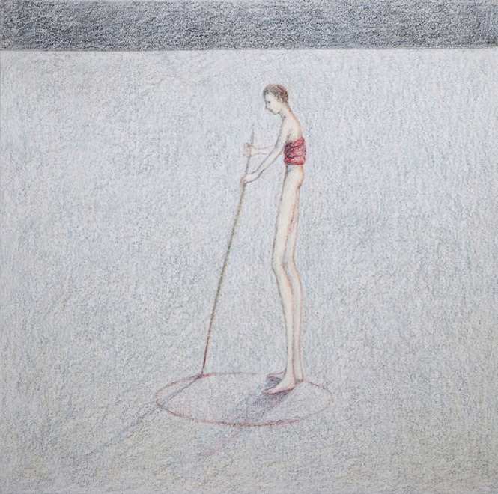

SPRINGFIELD, IL – The new exhibition “Sing Muses! History and Allegory in Narrative Art” opening February 23 at the Illinois State Museum in Springfield will spotlight narrative art from the ISM permanent collection.

“Historically, narrative art has combined both the historic and metaphysical, using allegorical figures to illuminate the relevant message of the moment,” said exhibition curator Doug Stapleton, Associate Curator of Art at the Illinois State Museum. “It strives to thrill, instruct, and caution its viewers, inviting them to step outside their day-to-day lives into dramatic moments of shared humanity.”

The artists in the “Sing Muses!” exhibition find that allegory, metaphor, and poetic license have not been dampened by modern reality. Instead they use it as a critical tool to examine personal, political and social issues, often through the historic lens provided by art history. The artists selected for this exhibition use the grand narrative tradition of the past to tell current stories of the struggles to understand humanity’s place in the modern world.

“Sing Muses!” features paintings, sculptures, and works on paper by Stanley Bly, Henry Darger, Glen C. Davies, Nicole Gordon, Billy Morrow Jackson, George Klauba, Shirley Mann, Nancy Plotkin, Filemon Santiago, Geoffry Smalley, and Kevin Veara.

The exhibition will run from February 23 to June 3. The public is invited to attend a “Museum After Hours: Preview Night” event on February 22 from 5:00 – 8:00 p.m. to see this exhibit and two others before they open on February 23. The evening will include live music, drinks from Obed and Isaac's Microbrewery and Danenberger Family Vineyards, and non-alcoholic beverages. Food will be available for purchase.

Tickets for Museum After Hours are $10 for members of the Museum Society and $15 for non-members. All tickets include a beverage, with additional beverages and food available for purchase. Tickets will be available at the door or online at bit.ly/mahfeb2019. All proceeds from the Museum After Hours series support educational programs at the Illinois State Museum. Attendees must be 21 or older and must show ID at the door.

The Illinois State Museum is located at 502 S. Spring Street. It is open Monday – Saturday, 9:00 a.m. to 4:30 p.m. and Sundays 12:00 noon – 4:30 p.m. Admission is $5 for adults ages 19-64.

###

Image above:

Nancy Plotkin

Untitled

No date (late 1980s)

colored pencil on paper

Illinois Legacy Collection, Gift of Andrew John Plotkin