**FOR IMMEDIATE RELEASE**

May 1, 2018

**Contact:**

Karen Everingham

Karen.Everingham@illinos.gov

217-782-5949

**Music at the Museum Features Greg Pasenko and Diane Deline on May 10 at the Illinois State Museum**

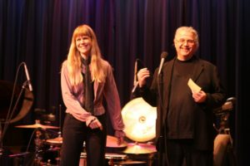

SPRINGFIELD, IL – The Illinois State Museum’s monthly “Music at the Museum” concert series on Thursday, May 10 at 7:00 p.m. will feature jazz from the husband and wife team of Greg Pasenko and Diane Deline.

Diane Deline is a violinist, composer, recording artist and educator. A former resident of Springfield, her jazz work has earned her the Downbeat Magazine’s Critics Poll “Rising Star” category four times. Diane will be joined by Chicago-based Blujazz recording artist Greg Pasenko. Pasenko is a dynamic jazz singer, guitarist, and composer who was featured at a performance for President Clinton. Together, this husband and wife team is both moving and intimate, covering vocal jazz standards, including tunes from “The American Songbook” like George Gershwin and Cole Porter, as well as original pieces.

Music at the Museum is a monthly concert series produced by Chris Vallillo featuring the best in contemporary and traditional folk and acoustic music of all styles. Concerts are held the second Thursday of each month at 7:00 p.m. in the Museum auditorium. Tickets are available at the door, priced at $10 for adults, and $8 for Museum members and children under 12.

For more information on the featured acts and a full series schedule, visit [www.ginridge.com/extras/music-at-the-museum](http://www.ginridge.com/extras/music-at-the-museum).