

FOR IMMEDIATE RELEASE
June 18, 2019

Contact: Robert Sill
217-524-5744

New Retrospective Exhibition on Work of Sculptor Thomas Skomski Opens June 22 at Illinois State Museum

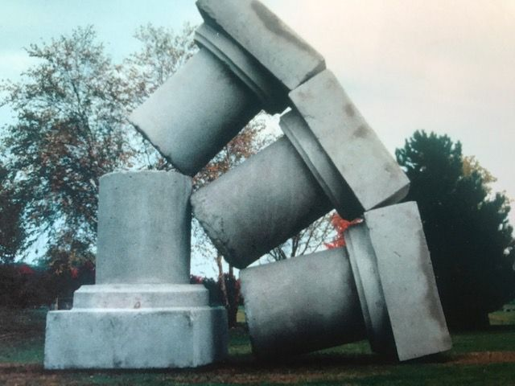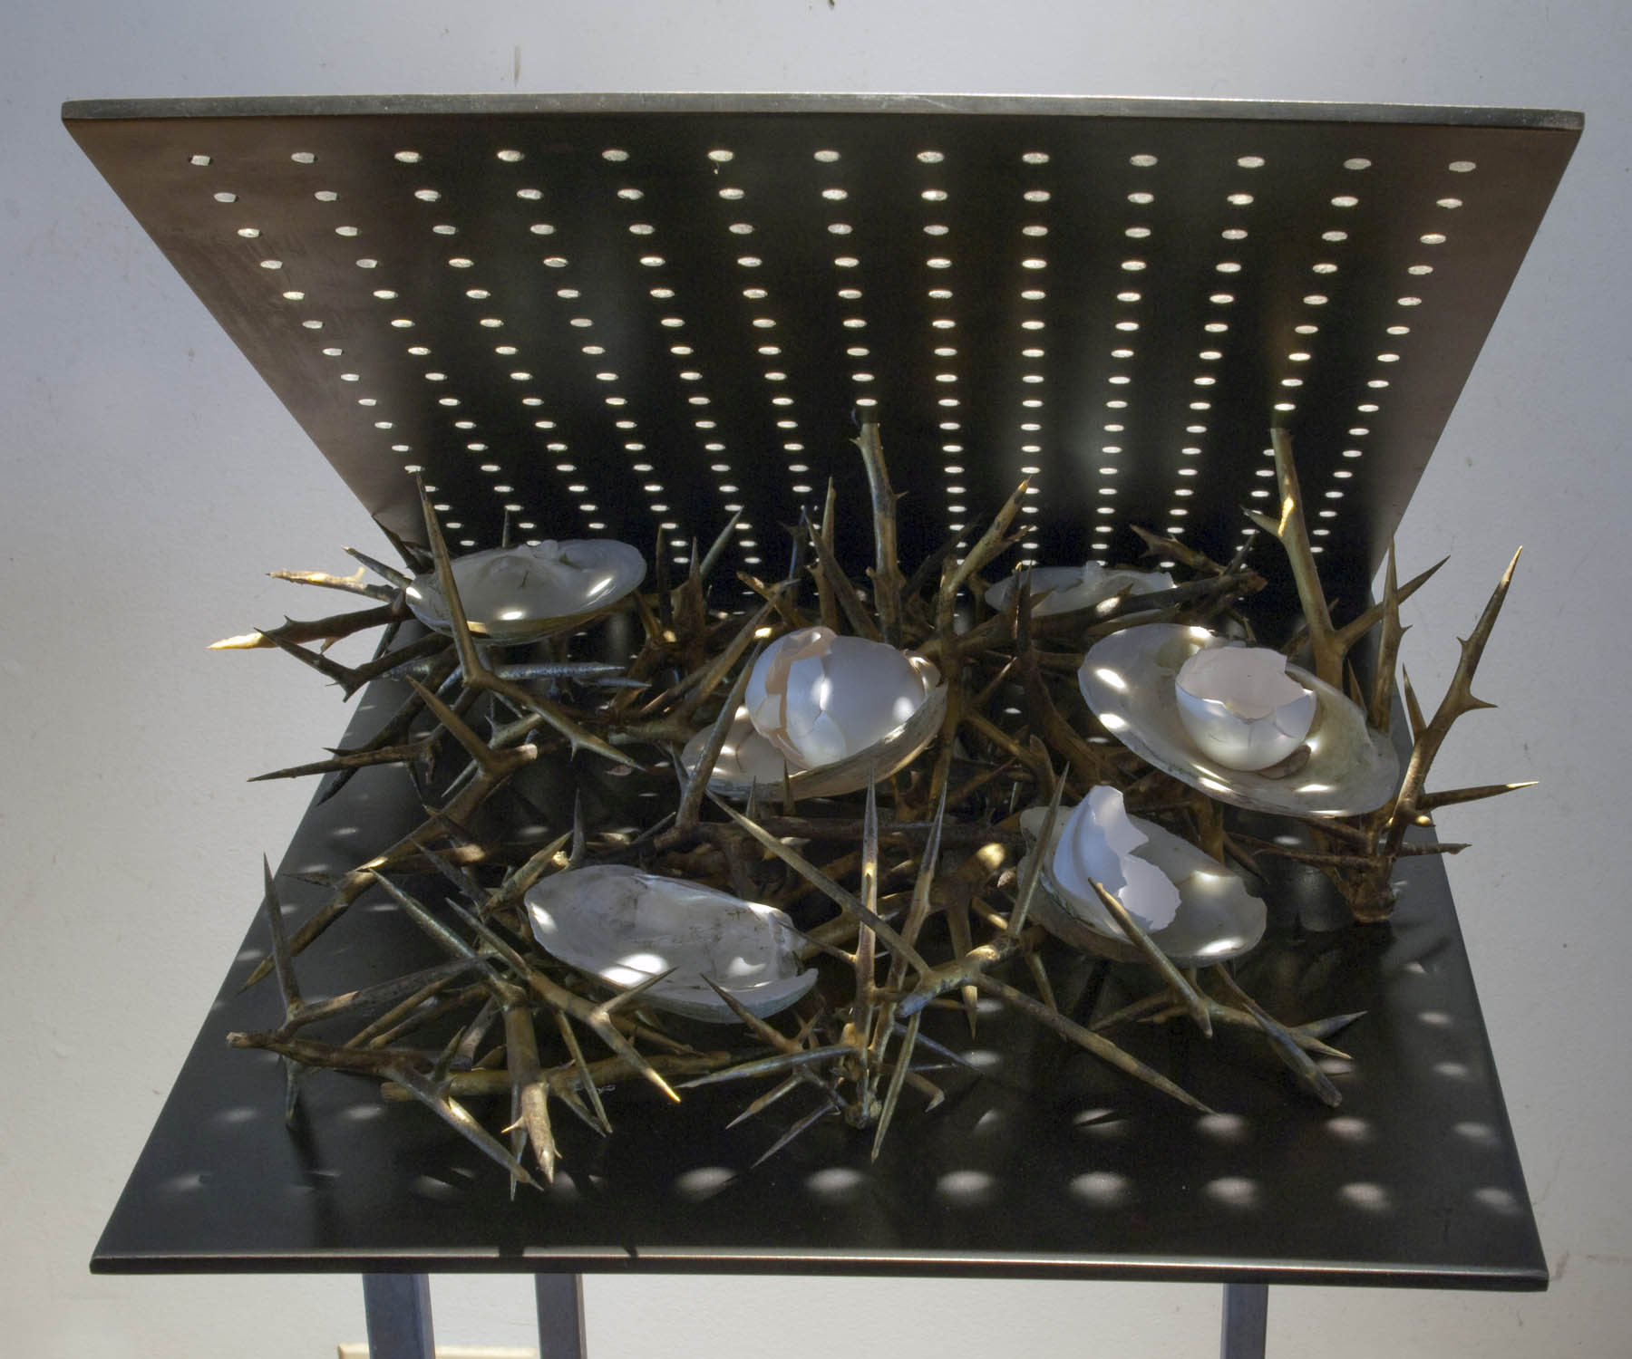

SPRINGFIELD, Ill. – The Illinois State Museum welcomes visitors to the new art exhibition URGENT CARE: Stuck in that Awkward Space between Birth and Death, which will open to the public on June 22.

This exhibition presents a 50-year survey celebrating the career of Thomas Skomski, one of Illinois’s finest sculptors. Springfield-area residents will know his work from the large public sculpture on the grounds of the University of Illinois Springfield campus that looks like a giant broken column called Impermanent Column.

“Thomas Skomski’s art honors life’s struggles; it reflects our times, it examines the processes of change and the inevitable outcome of decay and aging,” said Illinois State Museum Interim Director Robert Sill. “It’s art that mourns the losses and celebrates the precious and precarious nature of being alive!”

Among the sculptures filling the Museum art galleries as part of the new exhibition, viewers will find various recurring themes, subjects, and concerns.

“His entire oeuvre is a meditation on what it is to be ‘stuck in that awkward space between birth and death,’” said Sill.

From his earliest wood carvings, woodcuts and drawings of the 1970s to the cages, light boxes, water bottles, light manipulations and photographic images of the ‘80s and ‘90s up through his most recent works, Skomski’s fertile investigations into the human condition create art rich with ambiguities, analogies, and metaphors open to multiple interpretations.

The Illinois State Museum is open Monday through Saturday from 9:00 a.m. until 4:30 p.m. and Sunday from 12:00 p.m. until 4:30 p.m. The Museum is located at 502 South Spring Street in Springfield in the State Capitol Complex.

Admission is $5 for adults ages 19-64 and is free for youth, seniors, and veterans. In addition to the Springfield Museum, other public Museum facilities are found at the Dickson Mounds Museum in Lewiston and the Lockport Gallery in Lockport.

###

