

**FOR IMMEDIATE RELEASE**

May 23, 2019

**Contact:**

Elizabeth Bazan

217-558-6696

[Elizabeth.Bazan@Illinois.gov](mailto:Elizabeth.Bazan@Illinois.gov)

**Illinois State Museum Summer Pass Now Available**

*$10 pass for unlimited admission good Memorial Day through Labor Day*

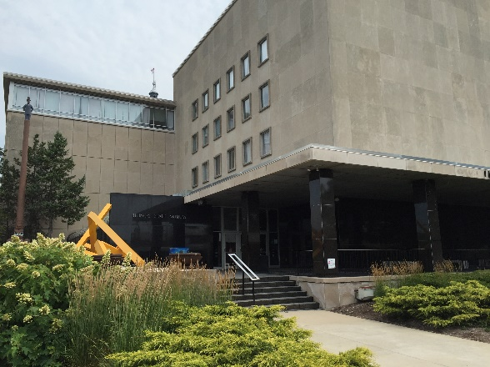

SPRINGFIELD, Ill – The fun and learning won’t stop this summer with the Illinois State Museum Summer Pass.

For $10, visitors to the Illinois State Museum in Springfield can purchase unlimited admission for one adult from Memorial Day through Labor Day. With the Summer Pass, visitors can enjoy admission to the Museum and all of this summer’s great programming including weekly tours, the Summer Film Fest, Super Saturdays, Story Times, and more.

The ISM Summer Pass can be purchased at the Illinois State Museum Admission Desk. Each Summer Pass is good for one adult admission during the Museum’s regular operating hours. Summer Pass holders are not entitled to Museum Society Membership benefits such as program discounts and members-only events. Regular Museum admission is $5 for adults ages 19-64. Admission for children, seniors, veterans, and military personnel is always free. Through Labor Day, admission is also free for the families of veterans and active duty military personnel through the Blue Star Museum program.

The 2019 ISM Summer Pass will expire September 2, 2019. The Museum is located at 502 S. Spring St., Springfield.