

**FOR IMMEDIATE RELEASE**

2/1/19

**Contact:**

Erika Holst  
217-782-7152  
[erika.holst@illinois.gov](mailto:erika.holst@illinois.gov)

**New Illinois State Museum Exhibit to Highlight Immigrants to Illinois**

*“We Are Illinoisans” Opens Feb. 23*

SPRINGFIELD, IL – Estanislao Goff came to Illinois from Mexico in 1918 to escape death at the hands of Pancho Villa’s guerillas. Pierre Menard came in 1791 to capitalize on the fur trade. Winifred Barringer came from England in 1946 as a war bride. Bettye Kelley came from Mississippi in 1963 to escape the racism of the Jim Crow South. All left behind familiar faces and places for the opportunity to build a better life in Illinois.

These individuals will be highlighted in “We Are Illinoisans,” a new exhibition opening at the Illinois State Museum in Springfield on February 23. The exhibit will explore the stories of 14 immigrants to Illinois between the 18th century and today, as well as feature a display of more than 100 photos of dozens more submitted by the people of Illinois of their immigrant ancestors. Objects on display include an inkwell belonging to Abraham Lincoln (who came to Illinois from Kentucky in 1830); a silk quilt made by Salome Enos (who came to Illinois from Vermont in 1821); an 1857 sketch of a German turnverein club by Conrad Rossi-Diehl (who came to Illinois from Germany in 1848); and the child’s coat worn by Immanuel Ahiable when he came to Illinois from Ghana in 1999.

The exhibition, curated by Erika Holst, Curator of Art and History at the Illinois State Museum, will run from February 23 to June 3. The public is invited to attend a “Museum After Hours: Preview Night” event on February 22 from 5:00 – 8:00 p.m. to see this exhibit and two others before they open on February 23. The evening will include live music, drinks from Obed and Isaac's Microbrewery and Danenberger Family Vineyards, and non-alcoholic beverages, and food will be available for purchase.

Tickets for Museum After Hours are $10 for members of the Museum Society and $15 for non-members. All tickets include a beverage, with additional beverages and food available for purchase. Tickets will be available at the door or online at bit.ly/mahfeb2019. All proceeds from the Museum After Hours series support educational programs at the Illinois State Museum. Attendees must be 21 or older and must show ID at the door.

The Illinois State Museum is located at 502 S. Spring Street. It is open Monday – Saturday, 9:00 a.m. to 4:30 p.m. and Sundays 12:00 noon – 4:30 p.m. Admission is $5 for adults ages 19-64.

Photo files available on request:

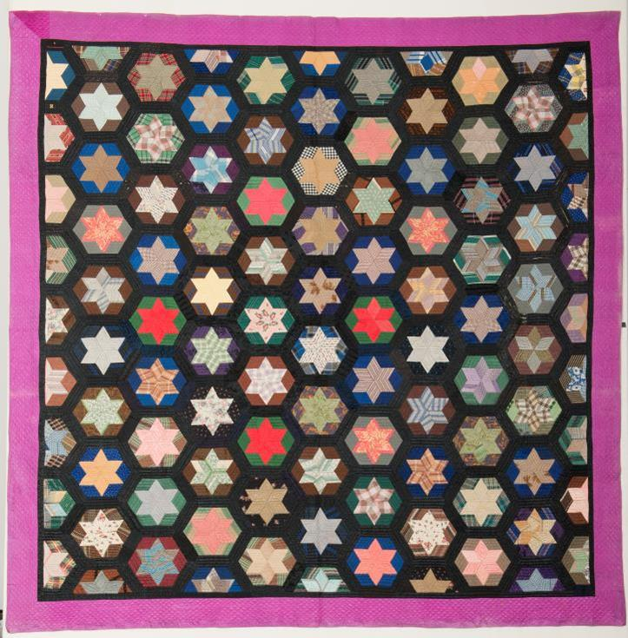

(photo of a silk quilt made by Salome Enos)